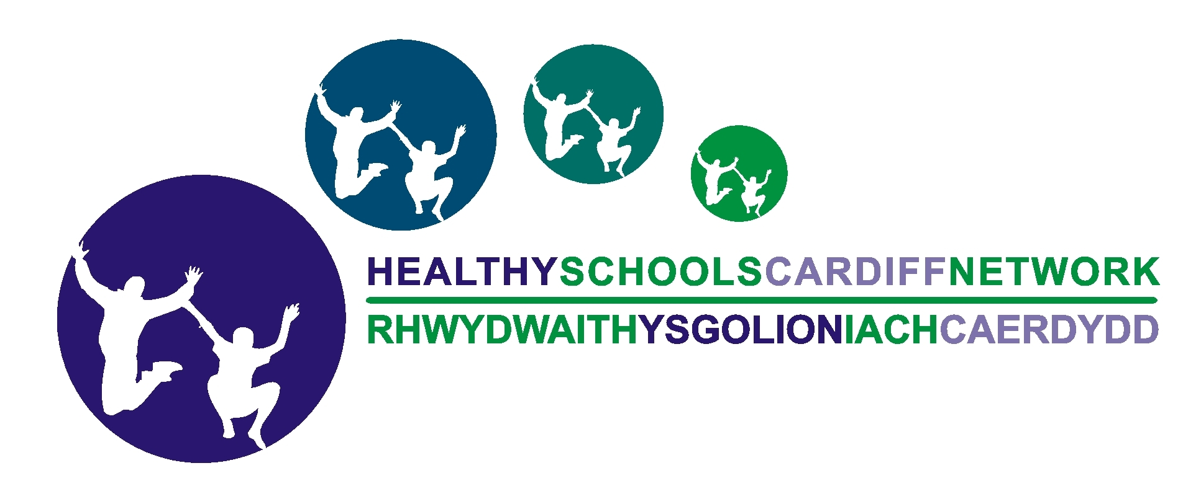    SRE / Personal Safety and Hygiene  for Foundation Phase |  |  |  | Year: Foundation phase – Aimed at Yr 1/2, could adapt for N/R  Term: |  | Time:  Lesson 3 of 4
LEARNING OBJECTIVES | LEARNING & TEACHING  SUGGESTED ACTIVITIES |  | RESOURCES & MATERIALS |  | FP AREA OF LEARNING | FP SKILLS / RANGE
Lesson 3: Secrets and People you can trust  To understand good and bad secrets and what feelings they may give you  To understand you should always tell someone you trust if a secret makes you feel worried or uncomfortable.  To be able to say ‘no’ and give an excuse if a stranger asks you to go with them  To be able to identify people you can trust if you need help. | This lesson can be a stand-alone lesson, or you may wish to recap on the previous lesson about good and bad touch, and our right to say ‘no’ if we don’t like something.  Keeping secrets – Ask the children what a ‘secret’ is and write their answers on the board e.g. ‘something you keep to yourself / don’t tell anyone else’. Ask them if they can think of any examples of a secret and note those on the board too. Discuss whether they think there can be ‘good’ secrets and ‘bad’ secrets and identify which ones they have listed are ‘good’ and which are ‘bad’ (add extra examples if necessary). Pupils could also do this as a sorting activity in pairs. Ask the pupils to explain their reasons why.  Scenarios – In groups, ask pupils to consider the following three scenarios. Scenario 1:  Jatinder’s mum was having a special birthday. Jatinder’s dad had invited lots of friends and family to the house. He told Jatinder not to tell anyone because the party was going to be a surprise for her mum.  (Continued overleaf…) |  | Whiteboard  Optional – make cards with different secrets on for pupils to sort into ‘good’ and ‘bad’ |  | Personal and Social Development, Well-being and Cultural Diversity | Personal Development –  Become independent in their personal hygiene needs and to be more aware of personal safety  Wellbeing –  Ask for assistance when needed
SRE / Personal Safety and Hygiene  for Foundation Phase |  |  |  |  | Year: FP (N – Yr 2)  Term: | Time:  Lesson 3 of 4
LEARNING OBJECTIVES | LEARNING & TEACHING  SUGGESTED ACTIVITIES |  | RESOURCES & MATERIALS |  | FP AREA OF LEARNING | FP SKILLS / RANGE
Questions:
- Is this a good secret or a bad secret? Why?
- What sort of feelings would a good secret give you? e.g. excited, happy

Scenario 2:
Annie is playing in her bedroom when her dad’s friend comes into her room and gives her a hug and a kiss. Her dad’s friend tells Annie it is a secret and she shouldn’t tell anyone.
- Is this a good secret or a bad secret? Why?
- What sort of feelings might a bad secret give you? e.g. worried, funny feeling in tummy, something doesn’t feel quite right

Discuss that no-one should be made / forced to keep any secret that makes them feel worried, sad or uncomfortable. It is especially important that they should not be asked to keep secrets that involve touch.
(Avoid discussions about abuse). Explain that if they are being asked to keep secrets by someone and they don’t understand why or it makes them feel uncomfortable, they should always tell someone they trust. (Continued overleaf…)
SRE / Personal Safety and Hygiene    for Foundation Phase |  |  |  | Year: Foundation phase (N – Yr 2)  Term: |  | Time:  Lesson 3 of 4
LEARNING OBJECTIVES | LEARNING & TEACHING  SUGGESTED ACTIVITIES | RESOURCES & MATERIALS |  |  | FP AREA OF LEARNING | FP SKILLS / RANGE
Scenario 3:
Brian is walking home from school when a neighbour stopped him. He asked Brian if he would like to go to his house at the weekend to play computer games, but he must not tell his parents.
Questions:
- Is this a good secret or a bad secret? Why?
- What should Brian say to his neighbour?
- What should Brian do when he gets home?

Practising saying ‘no’
Relating to the scenario above, ask the pupils what they should do if a stranger or someone they don’t know very well asks them to go with them, but their parents don’t know about it. (Say ‘no’). Tell the children they are going to work in pairs and practise saying ‘no’ and giving an excuse / reason e.g. ‘No, I have got to ask my mum first’, in response to different situations:

- Come with me, your mum asked me to pick you up.
- It’s raining, get into my car and I’ll take you home
(continued overleaf..)
SRE / Personal Safety and Hygiene  for Foundation Phase |  |  |  |  | Year: FP (N – Yr 2)  Term: | Time:  Lesson 3 of 4
LEARNING OBJECTIVES | LEARNING & TEACHING  SUGGESTED ACTIVITIES | RESOURCES & MATERIALS |  |  | FP AREA OF LEARNING | FP SKILLS / RANGE
- I’ve got some sweets you can have if you come with me.
- Come and play my new playstation game in the house.
- Please can you help me carry the shopping into the house?

Ensure children have several turns at saying ‘no’ and being the persuader. The excuse is important as children sometimes go with strangers as they cannot think of a reason not to when asked.

People you can trust – Lead a discussion and ask the children to think of different types of people that are helpful. Explain that people who can help you and you can trust might be different for different people. It might be a parent, carer, grandparent, brother or sister, teacher or police officer for example.
(Continued overleaf)…

SRE / Personal Safety and Hygiene  for Foundation Phase |  |  |  |  | Year: FP (N – Yr 2)  Term: | Time:  Lesson 3 of 4
LEARNING OBJECTIVES | LEARNING & TEACHING  SUGGESTED ACTIVITIES |  | RESOURCES & MATERIALS |  | FP AREA OF LEARNING | FP SKILLS / RANGE
 | N – Year 2 - Helping Hands activity - Ask the children to think about people in their life who they can trust and go to if they feel upset, worried or unsafe. Ask pupils to draw around their own hand on a piece of paper (and colour it if they wish). Ask the children to write the people they trust the most on each of the fingers. You should offer guidance on who this might be, but the children should create their own individual list and make it personal to them, not include generalised statements. The children could then keep their ‘helping hand’ somewhere safe.  Year 1 / 2 - Alternative activity (for more able) – concentric circles – People I could ask for help (see separate sheet)  Supporting session – Make sure the school also accesses the NSPCC ‘Speak Out Stay Safe’ programme for FP and KS2 - Free assemblies (FP & KS2) and workshops (KS2) www.nspcc.org.uk/schools  (Continued overleaf…) |  | A4 paper and pencils  Optional - concentric circles – ‘People I could ask for help’ sheet

SRE / Personal Safety and Hygiene  for Foundation Phase |  |  | Year: FP (N – Yr 2)  Term: | Time:  Lesson 3 of 4
LEARNING OBJECTIVES | LEARNING & TEACHING  SUGGESTED ACTIVITIES | RESOURCES & MATERIALS | FP AREA OF LEARNING | FP SKILLS / RANGE
 | If the pupils have already had the NSPCC workshops, remind them that there is the Childline number they can ring if they feel worried or upset. Ask if they can remember the number: 0800 1111.  Recap - review what has been learnt – There are good and bad secrets and always tell someone you trust if a secret makes you worried or uncomfortable (even if you’ve been told not to tell). If a stranger or someone you don’t know very well asks you to go with them – what should you do? Finally, remember all the people you decided were people you can trust and go to if you need help.  If the pupils have already learnt the NSPCC PANTS rules, remind them of the last 2 points (or ask if they can remember what the ‘T’ and ‘S’ in PANTS stands for):  - Talk about secrets that upset you  - Speak up, someone can help | NSPCC PANTS acrostic (see lesson 1)

