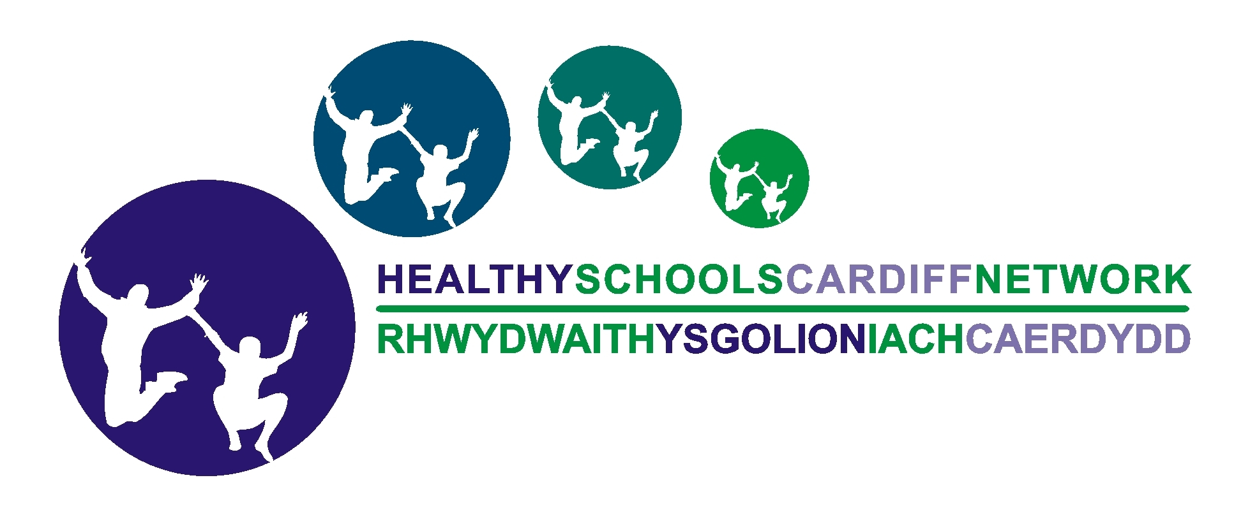    SRE / Personal Safety and Hygiene  for Foundation Phase |  |  | Year: Foundation phase – (suggested Year 1 / 2)  Term: |  | Time:  Lesson 2 of 4
LEARNING OBJECTIVES | LEARNING & TEACHING  SUGGESTED ACTIVITIES | RESOURCES & MATERIALS |  | FP AREA OF LEARNING | FP SKILLS / RANGE
Lesson 2: Touch  To understand there are different types of touch and different people like different things  To explore and express feelings around different types of touch  To understand that if someone touches you in a way you don’t like you can say no and ask them to stop | Recap on the previous lesson, regarding the NSPCC PANTS rule by looking at the PANTS acrostic. Recap on the names of the key body parts (penis, vagina and testicles). This can be done by drawing the outline of a body and the children placing pictures of the different body parts in the right place and saying the names.  Introduce that the class is going to be learning about different types of touch.  Introductory circle time activity – Use a bag of different textured objects to pass round for the children to identify the objects they like and don’t like to touch. Pupils can describe how it makes them feel. Graphs could be made to show the most popular and unpopular object. Highlight there is no right or wrong answer, that different people like different things.  Good and Bad touch - Ask pupils to call out / mind map all the different types of touch they can think of. Then discuss which ones they think are ‘good’ and ‘bad’ touch. This could be done as a Venn diagram or continuum line.  (Continued overleaf).. | Drawing materials  Pictures of body parts (in pack)  NSPCC PANTS acrostic  Bag of textured objects e.g. hairbrush, sandpaper, playdough, silky material, pebble etc. |  | Personal and Social Development, Well-being and Cultural Diversity | Personal Development –  Become independent in their personal hygiene needs and to be more aware of personal safety  Wellbeing –  Ask for assistance when needed
SRE / Personal Safety and Hygiene  for Foundation Phase |  |  |  | Year: FP (Yr 1/2)  Term: | Time:  Lesson 2 of 4
LEARNING OBJECTIVES | LEARNING & TEACHING  SUGGESTED ACTIVITIES | RESOURCES & MATERIALS |  | FP AREA OF LEARNING | FP SKILLS / RANGE
 | Highlight that not everyone will agree and that’s fine, and it can depend on who it is that is touching you. Say that good touch should make you feel happy and positive like hugs and kisses from a family member.  Talk about who might touch you and why e.g.  - To show affection (hug, kiss, cwtch) – family member  - To keep you safe (holding hands when crossing a road) – family member, child minder  - If you’re hurt or ill - doctors or nurses  Then talk about touch which might not feel good, but is sometimes necessary, e.g.  - Grabbing you to stop you running into a busy road (or other danger)  - Examination by a doctor or nurse (explain you can always ask for an adult you trust to be present at the same time, like a parent)  (Continued overleaf).. | Optional - Pictures to show examples

SRE / Personal Safety and Hygiene    for Foundation Phase |  |  | Year: Foundation phase (Year 1/2)  Term: |  | Time:  Lesson 2 of 4
LEARNING OBJECTIVES | LEARNING & TEACHING  SUGGESTED ACTIVITIES | RESOURCES & MATERIALS |  | FP AREA OF LEARNING | FP SKILLS / RANGE
Highlight to the children that if someone touches them in a way that they don’t like, or makes them feel scared or upset, they can say ‘no’ and ask them to stop. (If pupils are used to the term ‘rights’ this could be used as a discussion point).

Go through some scenarios so the children can discuss what they could do or who they could talk to:
Example scenarios:
- Another pupil leans on me all the time when we are sat on the carpet and it makes me uncomfortable
- Another pupil hits me on the arm when he / she is cross and it upsets me
- One of the children always tries to hold my hand in the playground and I don’t like it
- When my sister’s friend is round our house she keeps trying to play with my hair and I don’t like it
- One of the older boys picks me up every time he sees me. I don’t like it because he squashes me and it makes me feel silly.

(Continued overleaf)..
SRE / Personal Safety and Hygiene  for Foundation Phase |  |  |  | Year: Foundation phase  Term: | Time:  Lesson 2 of 4
LEARNING OBJECTIVES | LEARNING & TEACHING  SUGGESTED ACTIVITIES | RESOURCES & MATERIALS |  | FP AREA OF LEARNING | FP SKILLS / RANGE
In pairs, pupils can then role play and practise saying ‘No, I don’t like that’ and ‘Please stop…. (whatever the touch is)’ (e.g. use scenario 1, 3 or 4).

Recap – Review what the pupils have learnt. Ask the pupils to name some types of touch, remind them that people like different things and just because someone else thinks a touch is ‘good’ they don’t have to think the same. Ask the children to call out what they would do if someone touches them in a way they don’t like.
Emphasise the relevant sections of the NSPCC PANTS rules:
- Always remember your body belongs to you
- No means No

